ECEN 325

Lab 6: Diodes

Section 506

03/05/2020

Jason Gilman

TA: Mandela

**Calculations:**

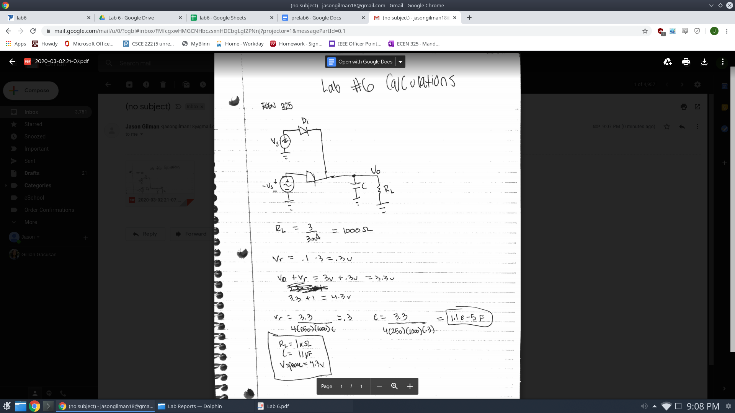

**Simulations:**

Diode Characterization Circuit

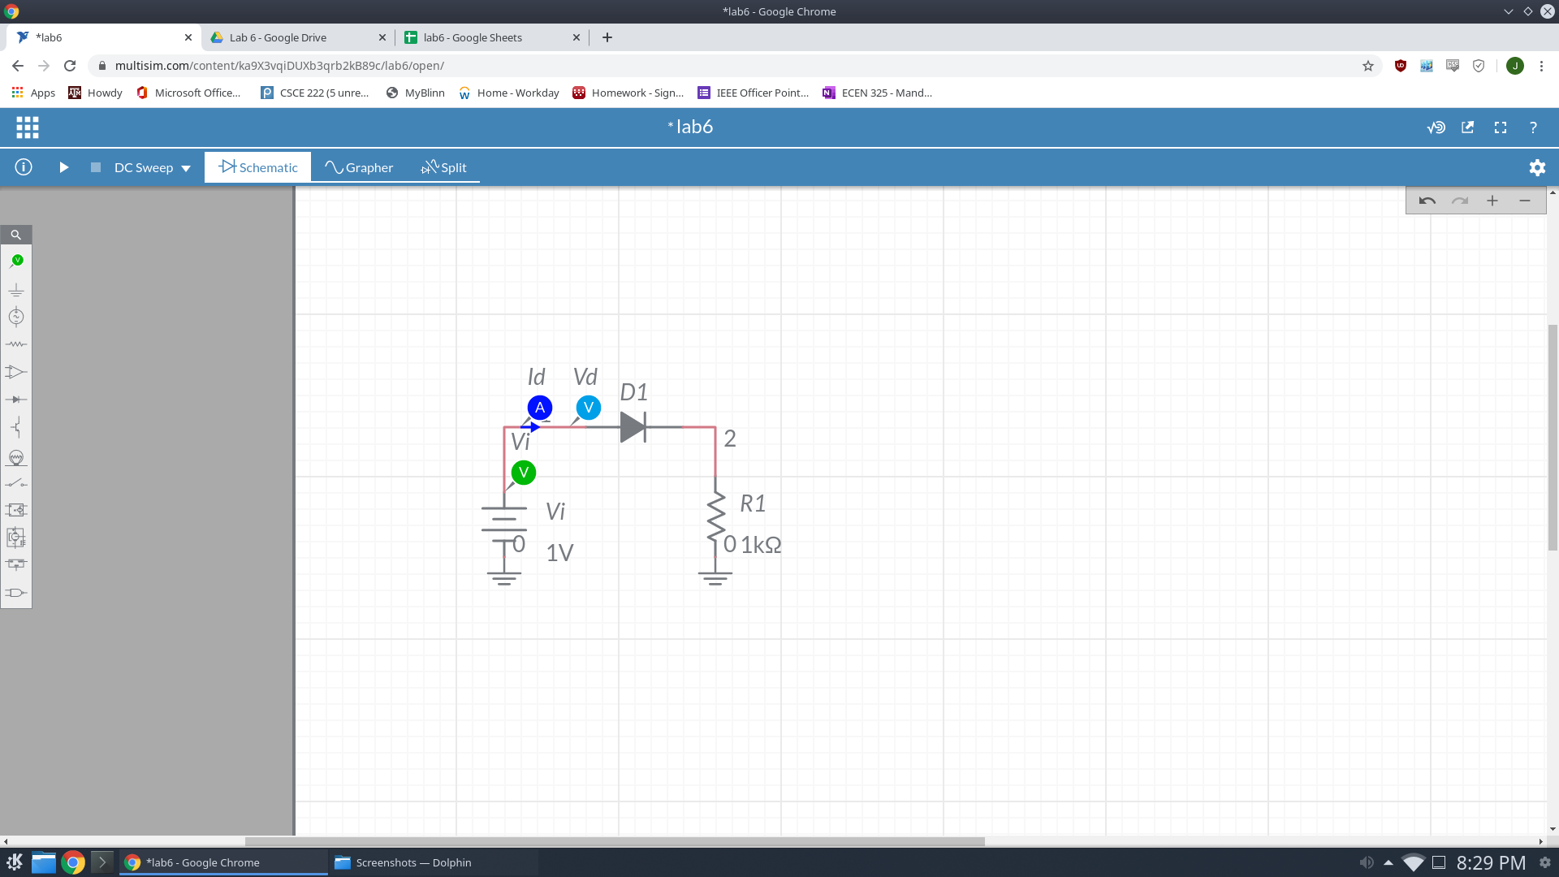

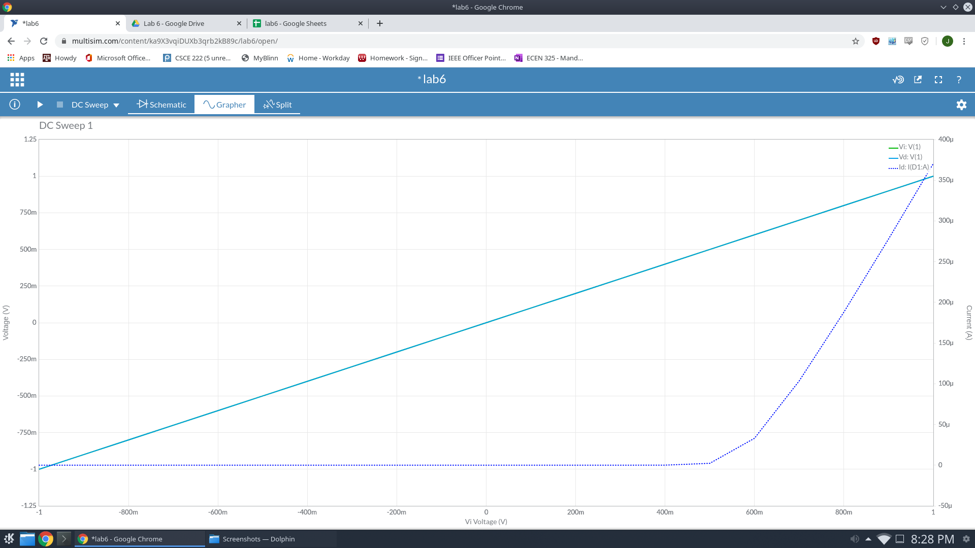

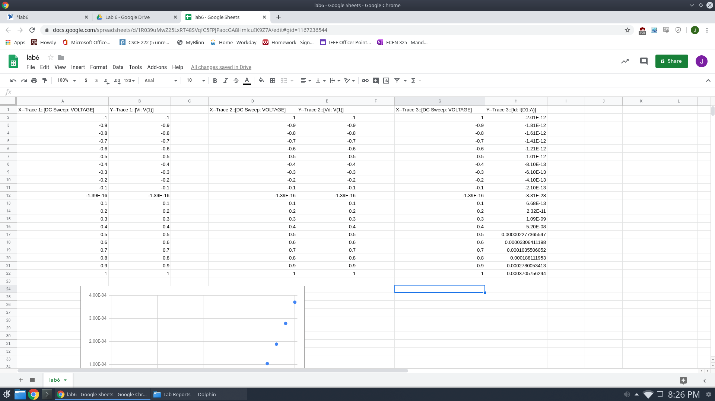

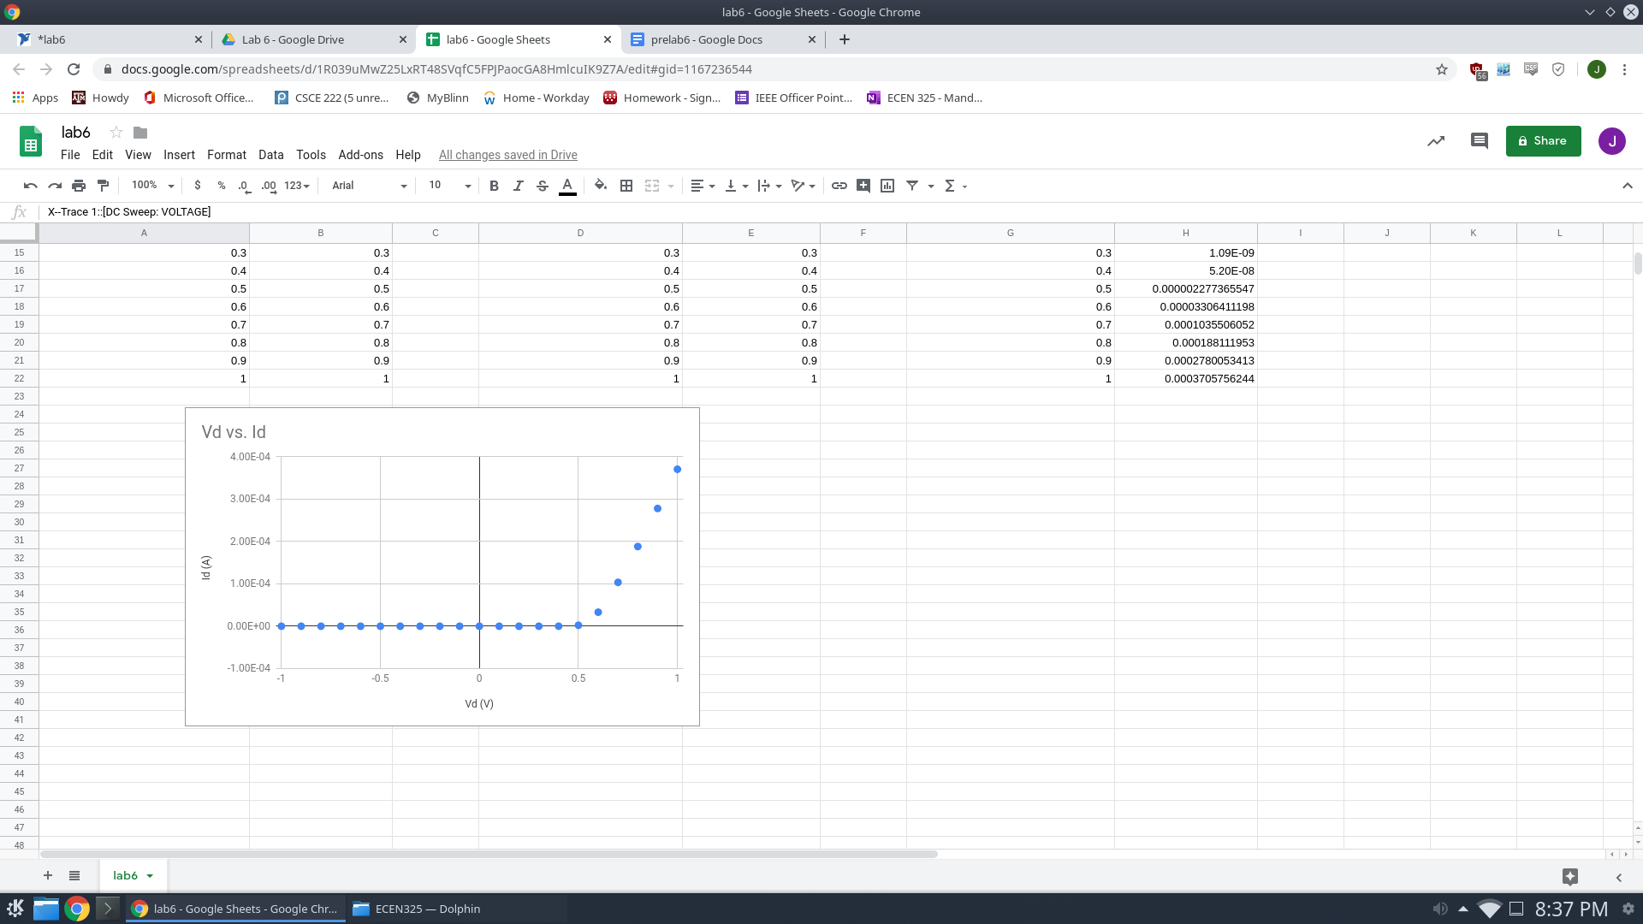

Power Supply Circuit

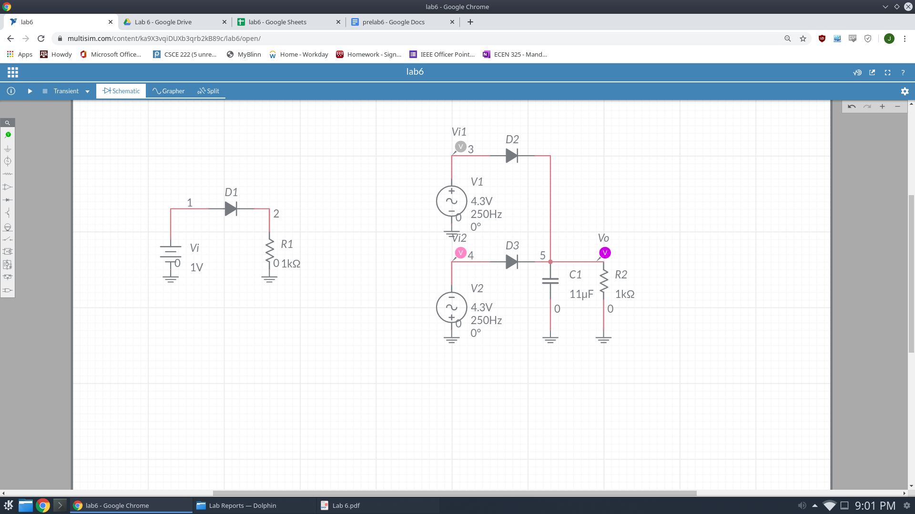

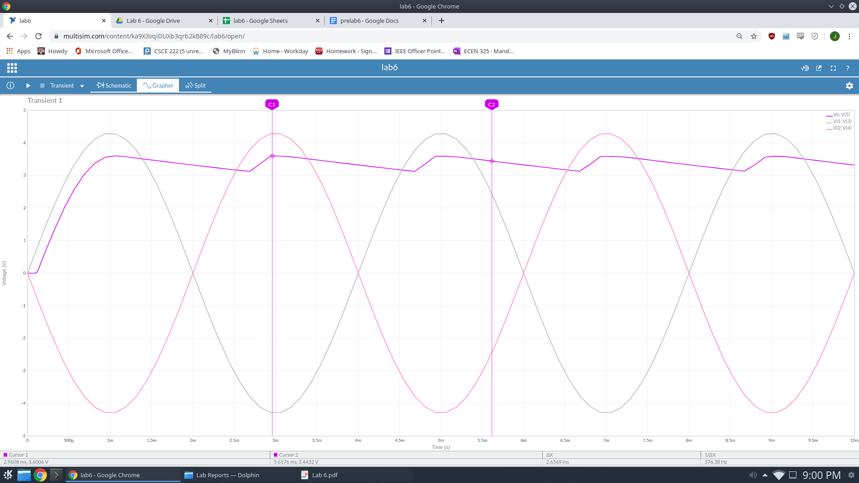

Vo peak = 3.6006 V

Maximum Ripple = 13.12%

**Measurements:**

Diode Characterization circuit Time-Domain Measurement

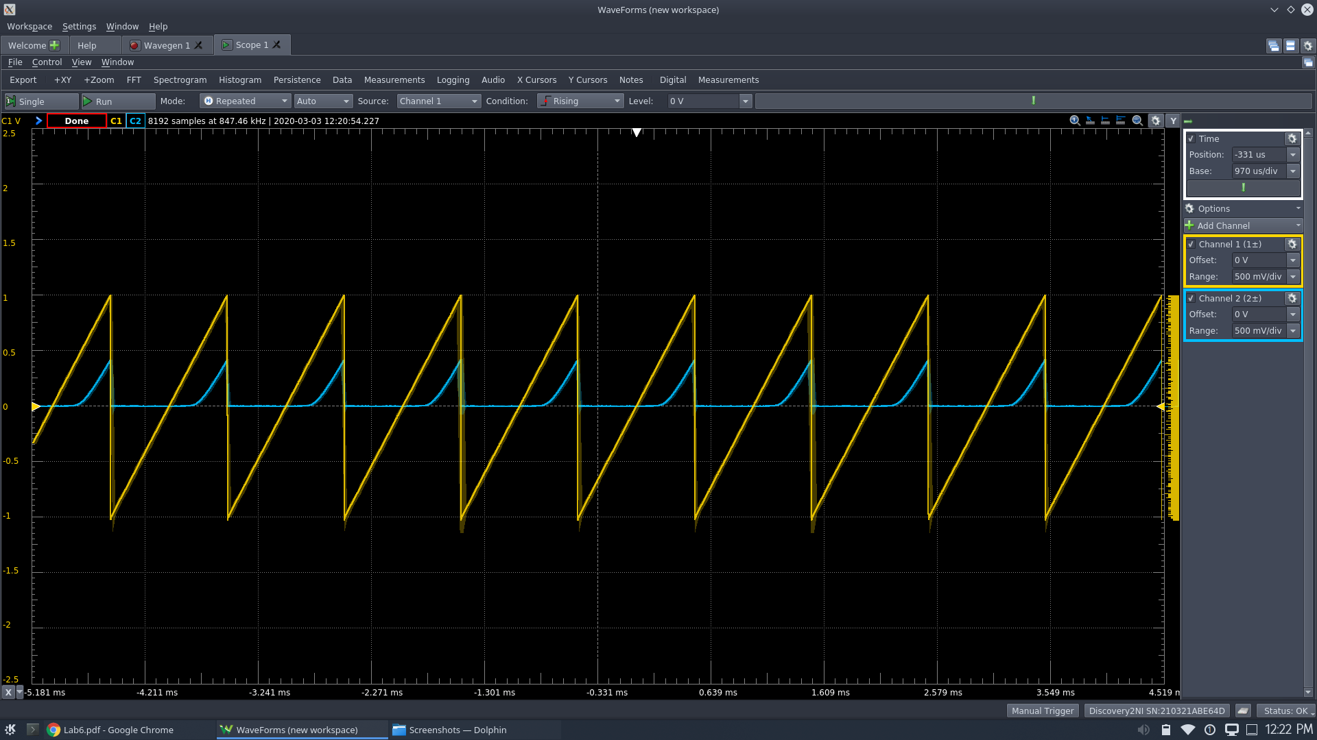

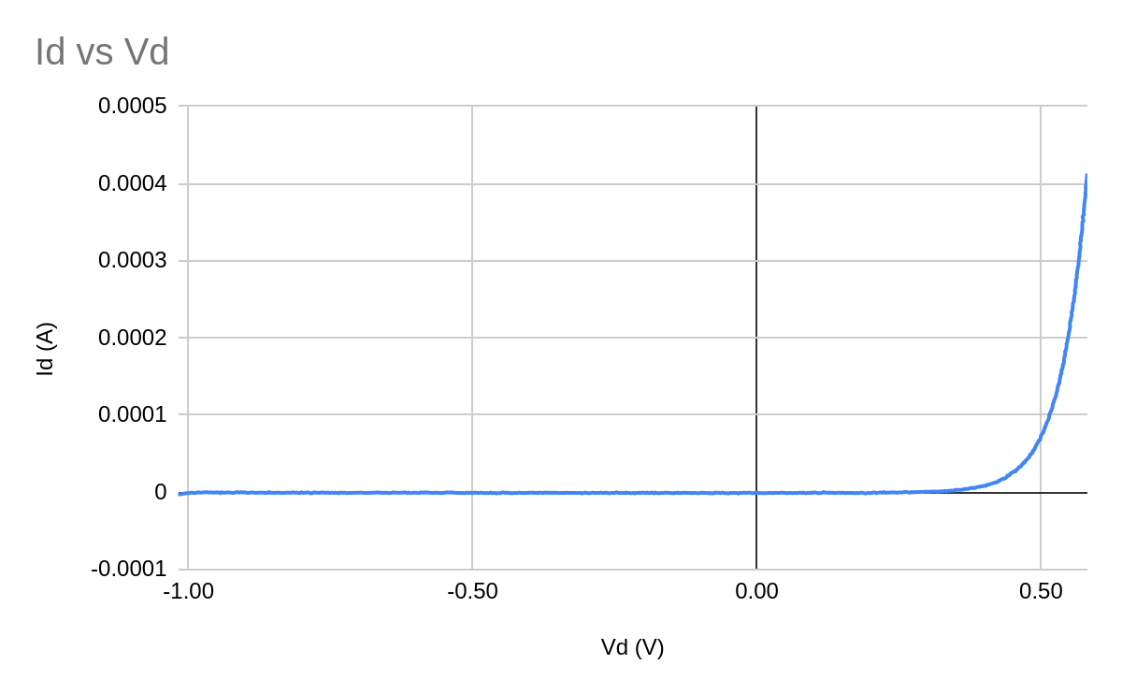

Power Supply Circuit Time-Domain Measurement

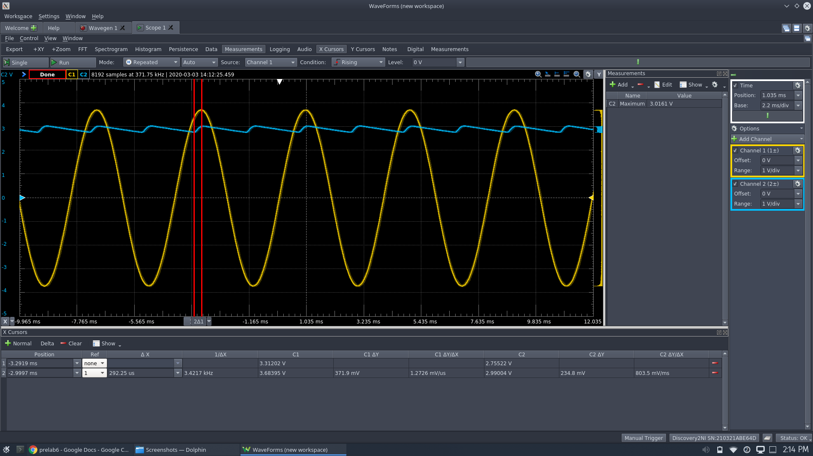

Vo Peak = 3.0161 V

Ripple Max = 7.784%

|  |  |  |  |
| --- | --- | --- | --- |
|  | Calculated | Simulated | Measured |
| Vo Peak | 4.3 V | 3.6 V | 3.0161 V |
| Ripple Max | 14.23 % | 13.12 % | 7.784% |

**Conclusion:**

Looking at the data, there is some difference between the measure, simulated, and calculated results. Specifically, the Vo peak, which influences the maximum ripple percentage, changes from each form of measurement. This could have been due to differences in the actual diode and capacitors used in the measurements and simulations.